
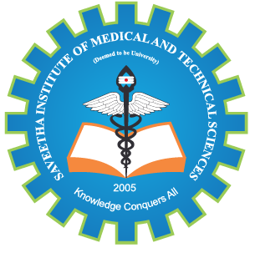
SIMATS ENGINEERING

Saveetha Institute of Medical and Technical Sciences
Chennai- 602105

Student Name: Athavan k Reg. No.:192524036
Course Code: CSA1507 Slot: A
Course Name: Cloud Computing For Big Data Analysis
Course Faculty: Dr. Anuradha C
Project Title: FOODLINK CLOUD: AI-ENABLED SMART FOOD RESCUE AND REDISTRIBUTION PLATFORM
Module Photographs: (2 photographs –Module Photo, Individual student contribution module work in the project and presentation image)
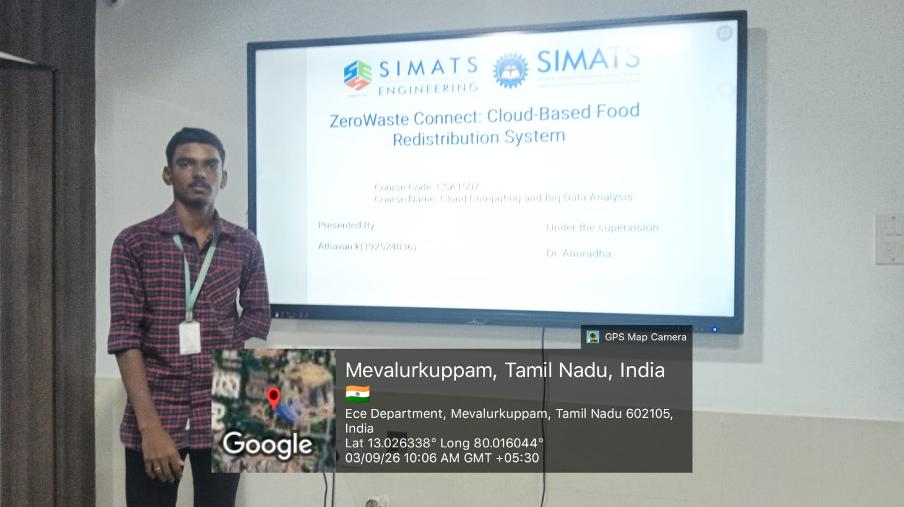
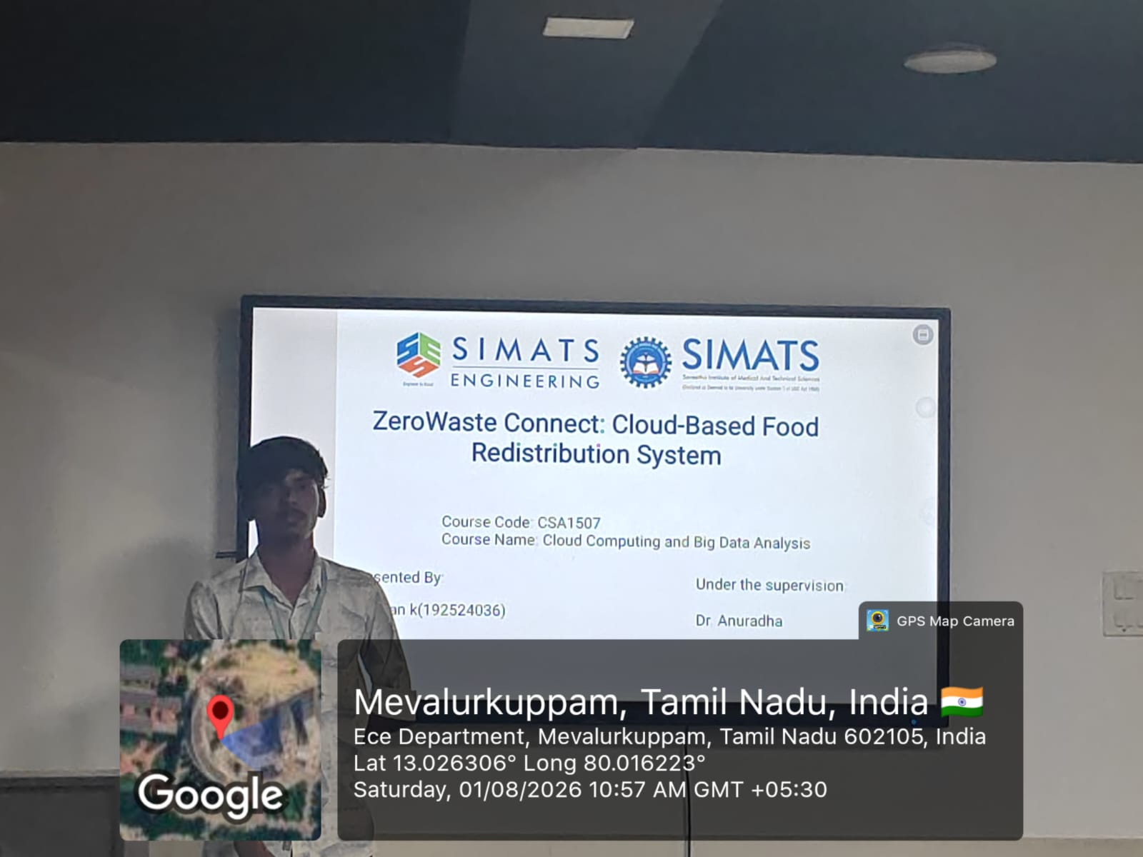
Project Description: ZeroWaste Connect: Cloud-Based Food Redistribution System is a cloud-based platform designed to reduce food wastage by connecting food donors such as restaurants, hotels, supermarkets, and event organizers with NGOs and food banks.
ZeroWaste Connect: Cloud-Based Food Redistribution System is a smart cloud-based platform designed to reduce food wastage by connecting food donors such as restaurants, hotels, supermarkets, and event organizers with NGOs and food banks. The system allows donors to upload surplus food details such as type, quantity, location, and expiry time, while NGOs can view available donations, accept suitable food, schedule pickups, and track deliveries. The cloud platform provides secure data storage, real-time notifications, location-based matching, and centralized monitoring. By ensuring that surplus edible food reaches people in need instead of being discarded, ZeroWaste Connect helps reduce food waste, improve food redistribution, support communities, and promote sustainable consumption and production.

Student Signature Guide Signature

Athavan K

